

**SCIENCE DEPARTMENT**

**YEAR 11**

**HUMAN BIOLOGY EXAMINATION**

**SEMESTER TWO 2008**

|  |  |  |  |  |
| --- | --- | --- | --- | --- |
| **Student Name:** |  |  | **Teacher:** |  |

**Time allowed for this paper**

**Reading time before commencing work: Ten minutes**

**Working time for paper: Three hours**

**section 1: Multiple Choice – 40 Questions – 40 Marks – 40%**Answer the multiple choice questions by crossing out the letter of your choice on the answer sheet provided.***Use a 2B pencil here.***

**SECTION 2: Short Answers –15 Questions –120 Marks – 40%**Answer the questions in the spaces provided. Answers are to be in BLUE or BLACK ink.  
***GRAPHS and DRAWINGS to be in pencil and labelled in ink.***

**SECTION 3: Extended Answer – 2 Questions – 40 Marks – 20%**Answer question 16 **OR** question 17  
**AND**  
Answer question 18 **OR** question 19.

**SECTION 2: SHORT ANSWER SECTION 120 MARKS**

**Fill in all answers in this booklet.**

**Spelling and grammar will count towards your mark.**

**This section is worth 40%.**

**Good luck.**

_______________________________________________________________________________

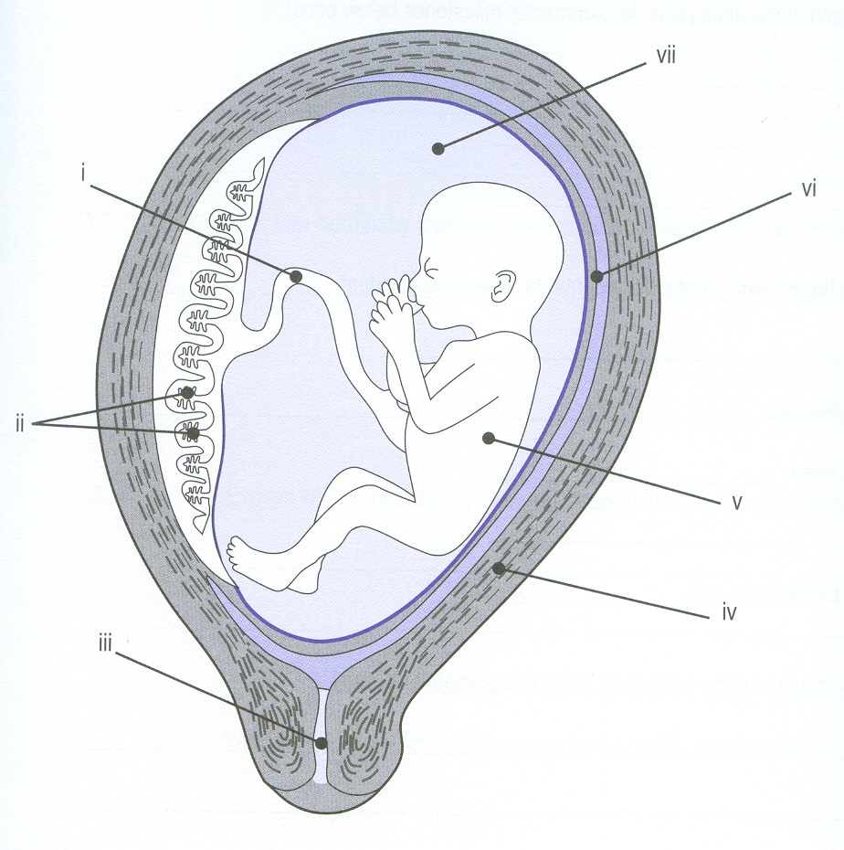

1. Label the diagram above:

(i) _______________________________________

(ii) _______________________________________

(iii) _______________________________________

(iv) _______________________________________

(v) _______________________________________

(vi) _______________________________________

1. _______________________________________ (7 marks)

2. Describe the function of the following parts from the diagram above in Question 1:

(ii)

________________________________________________________________________

________________________________________________________________________

(iii)

________________________________________________________________________

________________________________________________________________________

(2 marks)

3. (i) Why is blood diverted away from the foetal lungs?

________________________________________________________________________

________________________________________________________________________

(1 mark)

(ii) Describe how blood is diverted away from the foetal lungs?

________________________________________________________________________

________________________________________________________________________

________________________________________________________________________

________________________________________________________________________

(3 marks)

4. Which part of the baby is normally delivered first?

________________________________________________________________________

What hormone is involved in the contractions in parturition?

________________________________________________________________________

Where is this hormone released from?

_______________________________________________________________________

(3 marks)

5. Using “Rubella” as an example, explain how this environmental factor can affect the foetus with non-heritable changes.

________________________________________________________________________

________________________________________________________________________

________________________________________________________________________

________________________________________________________________________

________________________________________________________________________

________________________________________________________________________

________________________________________________________________________

________________________________________________________________________

________________________________________________________________________

________________________________________________________________________

________________________________________________________________________

(4 marks)

6. Describe 4 changes that occur in the “puerperium period.”

|  |  |
| --- | --- |
| 1 |  |
| 2 |  |
| 3 |  |
| 4 |  |

(4 marks)

7. The following graph shows the results of an experiment involving the breakdown of starch by an enzyme.

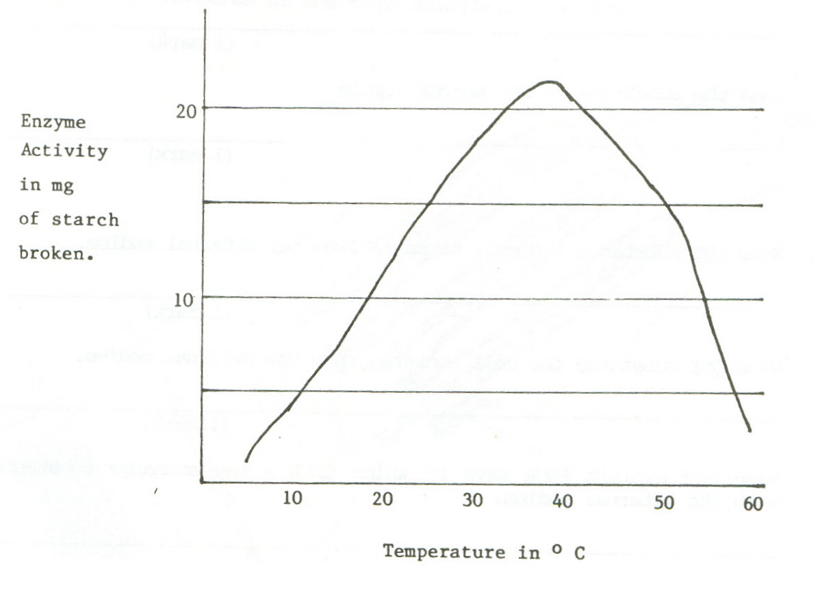

(a) What is the optimum (best) temperature for the activity of this enzyme?

________________________________________________________________________

(1 mark)

(b) Why does the rate of reaction drop rapidly at body temperatures above 450C?

________________________________________________________________________

________________________________________________________________________

(2 marks)

(c) What is the end product of digestion of starch?

________________________________________________________________________ (1 mark)

(d) How would you test for this end product?

________________________________________________________________________

________________________________________________________________________

________________________________________________________________________

(2 marks)

(e) Describe one factor, other than temperature, which affects the activity of an enzyme.

________________________________________________________________________

________________________________________________________________________

(2 marks)

(f) Name the substrate of the enzyme sucrase?

________________________________________________________________________ (1 mark)

8. The diagram below shows a microscopic view of the wall of the ileum. One of the functions of the ileum is absorption of digested food.

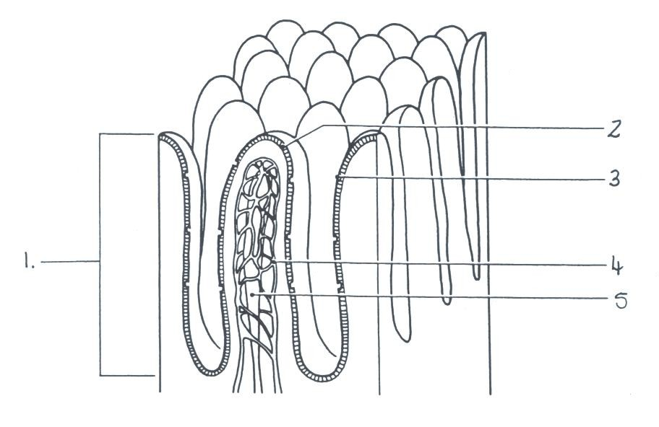

(a) Name each of the following structures and explain how they aid in the process of absorption. (6 marks)

|  |  |  |
| --- | --- | --- |
|  | **NAME:** | **EXPLANATION** |
| 1 |  |  |
| 4 |  |  |
| 5 |  |  |

(b) Name and describe one other way in which the structures shown in the diagram are particularly well suited to their function of absorption of food.

|  |
| --- |
|  |
|  |

(2 marks)

(c) Label the following from the diagram of the digestive system shown below .

|  |  |
| --- | --- |
| A ____________________________ | C __________________________ |
| B ____________________________ | D __________________________ |

(4 marks)

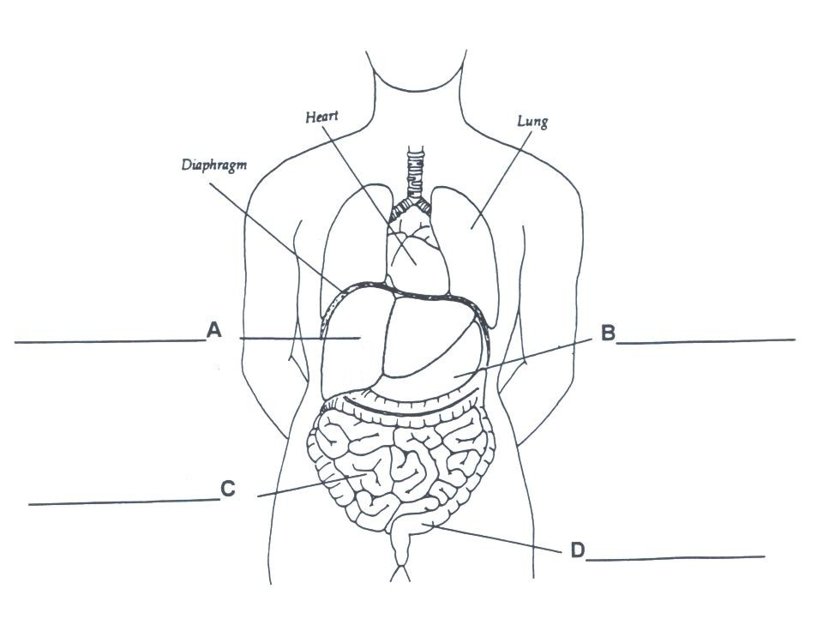

1. Behind organ **B**, is another organ that has a vital role in digestion.

(i) Name this organ:___________________________________________ (1 mark)

(ii) Describe one function of this organ (in relation to digestion)

__________________________________________________________ (2 marks)

9.

1. Label the following structures shown from the diagram in the table below.

ANTERIOR VIEW OF LONGITUDINAL SECTION OF THE HEART

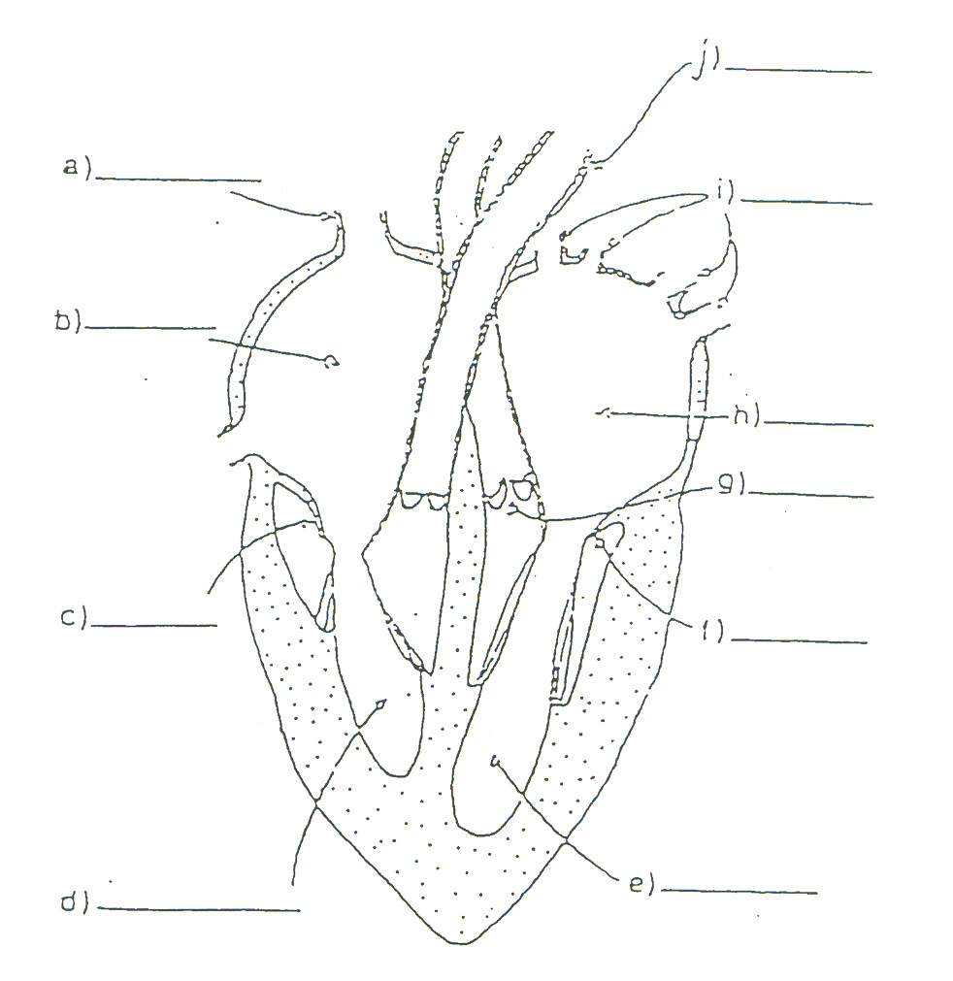

|  |  |
| --- | --- |
| b |  |
| c |  |
| d |  |
| i |  |
| g |  |
| j |  |

(6 marks)

(6 marks)

(b) Explain the functions of the following structures.

|  |  |
| --- | --- |
| SEPTUM |  |
| AORTA |  |
| BICUSPID VALVE |  |

(3 marks)

(c) On these smaller diagrams, using a solid line and arrows show the passage through the heart of oxygenated blood on diagram A and deoxygenated blood on Diagram B. (4 marks)

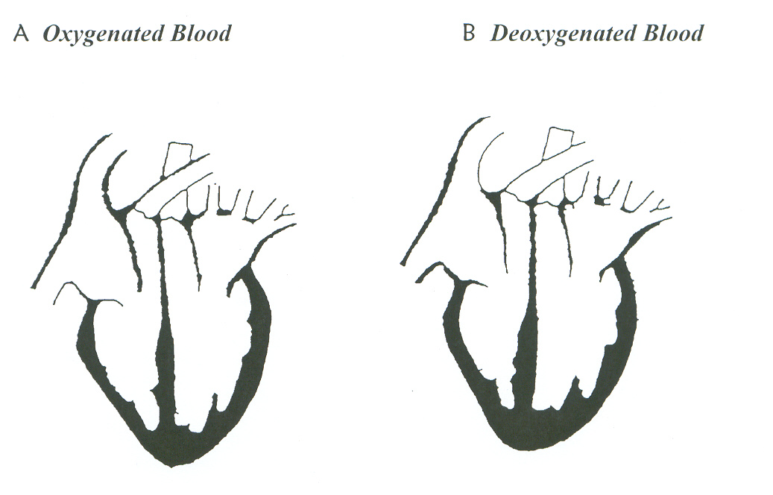

(d) Explain the term “diastolic”.

________________________________________________________________________

________________________________________________________________________

________________________________________________________________________

(2 marks)

1. Describe what would happen if the chordae tendonae were severed or broken?

________________________________________________________________________

________________________________________________________________________

(1 mark)

1. Describe the two major functions of the lymphatic system? (i)____________________________________________________________________________

(ii)____________________________________________________________________________

(2 marks)

1. What is the name given to the medical condition caused when:

(i) there is a complete blockage in a coronary artery

______________________________________________________________________________

(ii) the heart ceases to act as a pump

______________________________________________________________________________

(2 marks)

10. Refer to the diagram below.

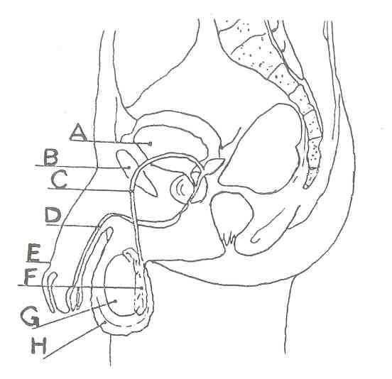

(a) Label the following parts from the diagram above. (5 marks)

|  |  |
| --- | --- |
| C |  |
| D |  |
| F |  |
| G |  |
| H |  |

(b) Which structure produces the hormone responsible for male secondary sexual characteristics? (1 mark)

|  |
| --- |
|  |

(c) In which organ is mature sperm stored? (1 mark)

|  |
| --- |
|  |

(d) Name the part of the male reproductive system which produces thin, milky, alkaline fluid. (1 mark)

|  |
| --- |
|  |

(e) Through which structure do sperm leave the body? (1 mark)

|  |
| --- |
|  |

(f) The testes develop in the abdominal cavity then descend into the scrotal sac. Why is it necessary for the testes to descend into the scrotum? (1 mark)

|  |
| --- |
|  |
|  |
|  |

(g) Vasectomy is an operation used to sterilise men. Explain what structures are operated on and how the technique prevents conception. (2 marks)

|  |
| --- |
|  |
|  |
|  |

(h) Describe 2 modes of operation of a spermicide. (2 marks)

|  |
| --- |
|  |
|  |
|  |
|  |

11. The diagram below shows partly how the hypothalamus regulates the menstrual cycle. Use this diagram to complete the questions below.

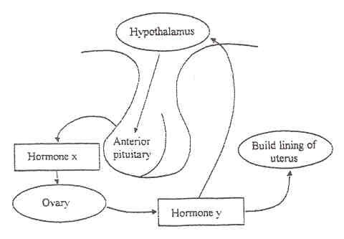

(a) Name and describe the function of hormone **X.** (3 marks)

|  |
| --- |
|  |
|  |
|  |

(b) Name the main hormone which is produced from the ovary in the first half of the

ovarian cycle? (1 mark)

|  |
| --- |
|  |

(c) Around day 12-13 of the menstrual cycle the pituitary releases another hormone.

(i) What is it called? (1 mark)

|  |
| --- |
|  |

(ii) What effect does this hormone have? (2 marks)

|  |
| --- |
|  |
|  |

(d) The ovary secretes another hormone in increasing amounts after day 14 of the

menstrual cycle. Name the hormone and state its purpose. (2 marks)

|  |  |
| --- | --- |
| Hormone |  |
| Purpose |  |
|  |  |

12. (a) Label the following from diagram below. (4 marks)

|  |  |
| --- | --- |
| **Part** | **Name:** |
| **B** |  |
| **C** |  |
| **F** |  |
| **G** |  |

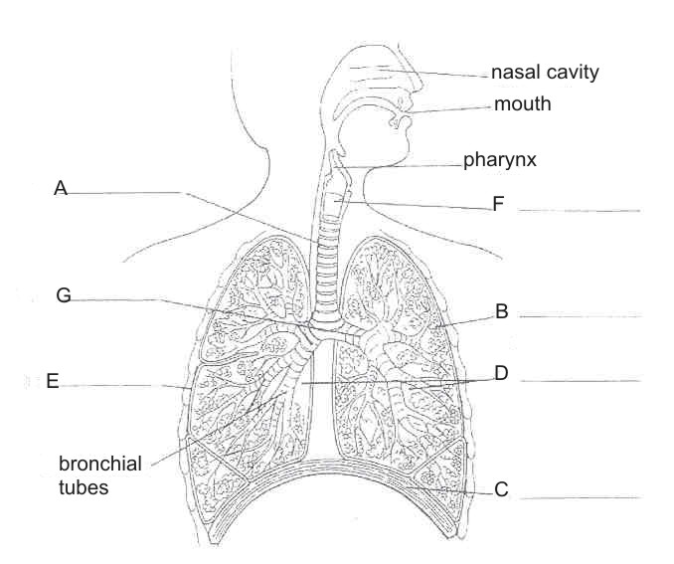

(b) What is the name of the space in which the heart lies? (1 mark)

|  |
| --- |
|  |

(c) What is the name of the fluid covering B? (1 mark)

|  |
| --- |
|  |

(d) Describe the function of C during (2 marks)

(i) inspiration

|  |
| --- |
|  |

(ii) expiration

|  |
| --- |
|  |

(e) Describe the purpose of the cartilage located in structure A. (1 mark)

|  |
| --- |
|  |

(f) Describe THREE ways the nasal cavity cleanses air that is inspired. (3 marks)

|  |  |
| --- | --- |
| (i) |  |
| (ii) |  |
| (iii) |  |

13. Refer to graphs A and B below which show changes in height and weight of children between 4 and 18 years of age.

**A – BOYS B - GIRLS**

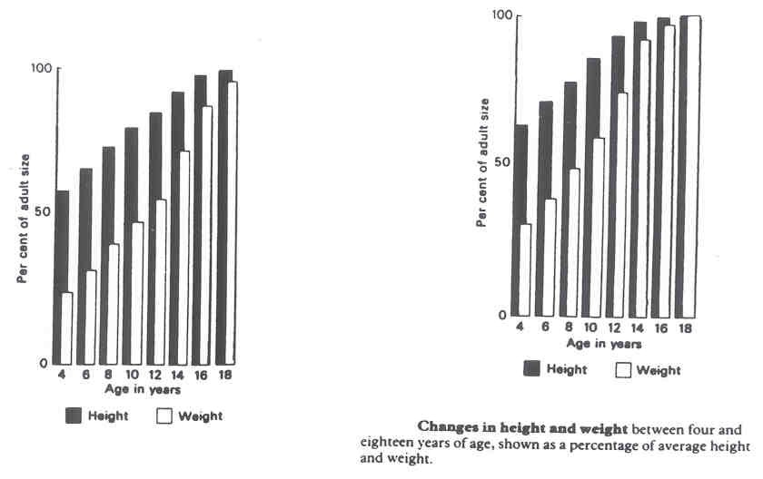

(a) Which sex reaches approximately 50% of adult body weight first? (1 mark)

|  |
| --- |
|  |

(b) At what age does this occur? (1 mark)

|  |
| --- |
|  |

(c) At what age do boys reach 98% of adult height? (1 mark)

|  |
| --- |
|  |

(d) At what age do girls reach 70% of adult weight? (1 mark)

|  |
| --- |
|  |

14. List two changes that occur to each of the following during ageing.

|  |  |
| --- | --- |
| INTEGUMENTARY SYSTEM | 1. |
|  | 2. |
| BONE TISSUE | 1. |
|  | 2. |

(4 marks)

15. Complete the following table.

|  |  |  |
| --- | --- | --- |
|  | **Herpes** | **Hepatitis B** |
| Cause |  |  |
| Symptoms |  |  |
| Treatment |  |  |

(9 marks)